**Project – 2**

**Deploying a web server in Windows instance**

**Task 1:** Create a windows instance using AMI :Ubuntu Server 18.04 LTS (HVM)

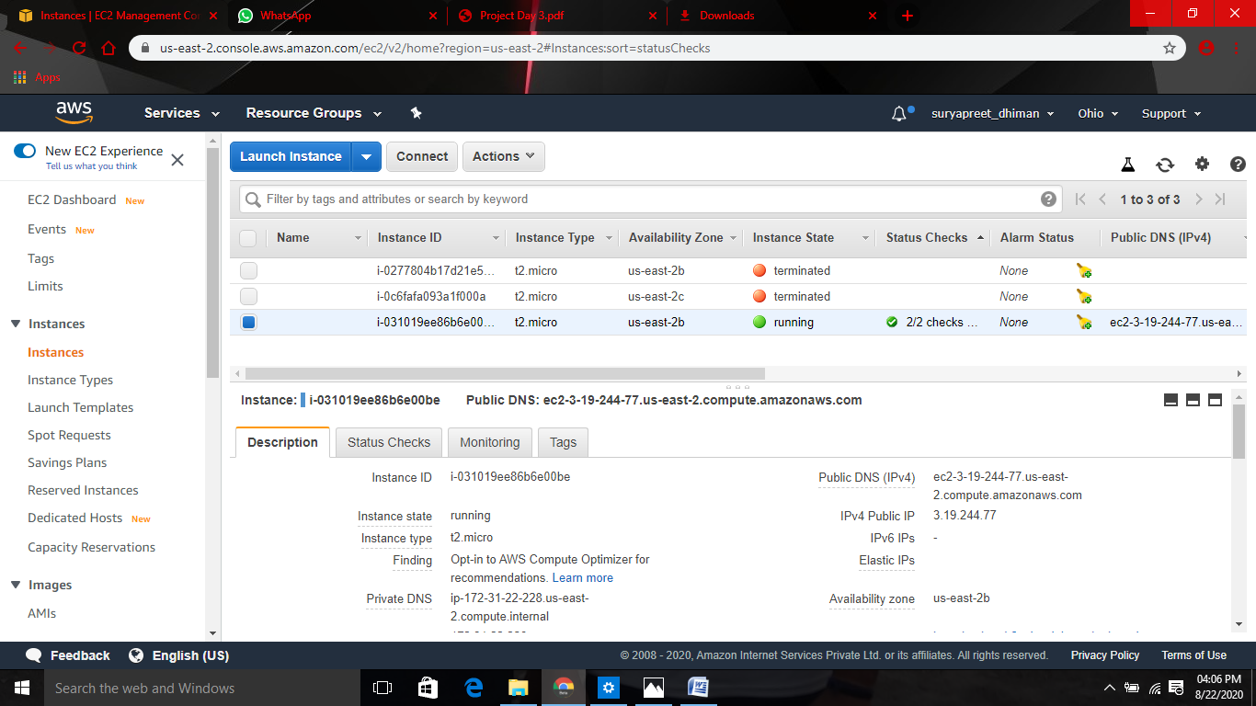

**Task 2:** Download and install MobaXterm Portable Edition

**Task 3:** Launch the Ubuntu instance using SSH Note (username : ubuntu)

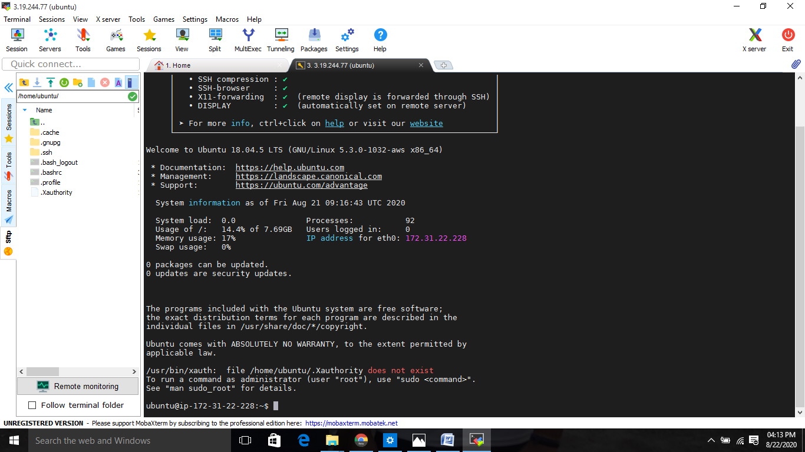

**Task 4:** Install NGNIC web server using bash

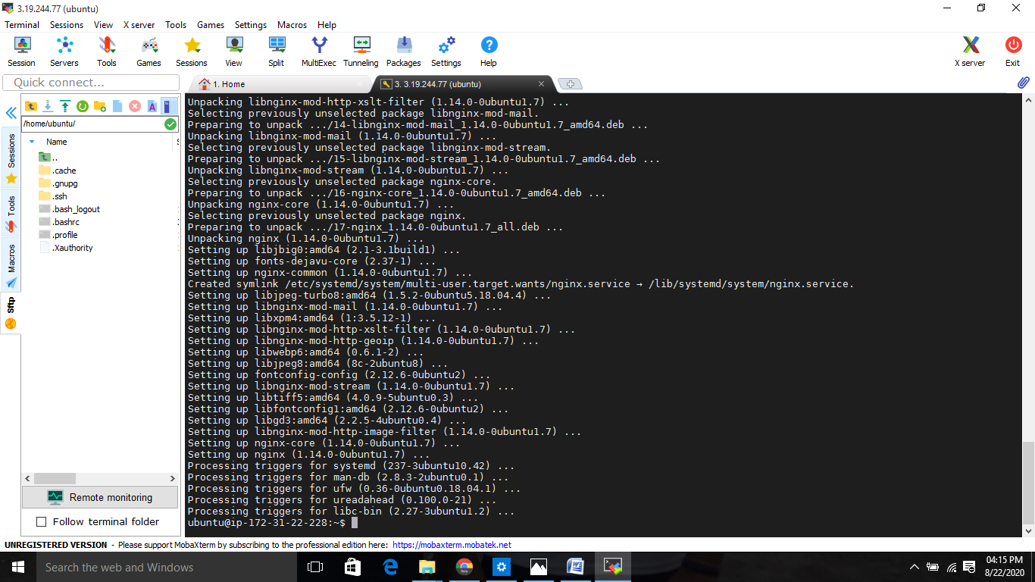

**Task 5:**Verify successful installation of ngnix

